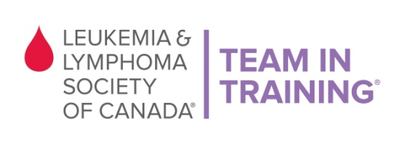

VOLUNTEER SIGN UP FORM

Thank you for volunteering your time with Team In Training at the Vancouver Chilly Chase on Sunday, January 24th, 2016.

Please register by Wednesday, January 20th before 5pm.

About TNT: Team In Training is a comprehensive endurance-training program for runners and walkers to benefit The Leukemia & Lymphoma Society of Canada. The goal of Team In Training is to increase funding to support LLSC’s mission while promoting fitness and healthy lifestyles.

Full Name (required): | Age (if under 19):
Address: | City:
Phone: | Postal Code:
T-shirt Size (required): | E-mail (required):
Volunteer Opportunities

- Water station
- Race Package/Race Chip hand out
- Road marshaling
- Set-up/Clean-up

Event Details
- Sunday, January 24th, 2016
- Duration time: 7:30am (approx. - TBA) – 11:00am
- Location: Seawall behind Creekside Community Recreation Centre

LLS Waiver of Liability: I recognize and understand that there are risks associated with being a volunteer for The Leukemia & Lymphoma Society of Canada. I hereby waive and release any and all claims for injuries or damages I have against The Leukemia & Lymphoma Society of Canada, its directors, employees and other race volunteers caused by the negligence of any of them arising out of my participation as a volunteer. I, for myself and anyone entitled to act on my behalf, waive and release any and all claims for injuries or damages I have against The Leukemia & Lymphoma Society of Canada, its Directors and employees, any and all municipalities associated with the event I may be attending, the province of British Columbia, race volunteers, sponsors and/or their agents and representatives, caused by the negligence of any of them arising out of my participation in this event. I understand that as a volunteer I will not receive remuneration for the time or services I provide to The Leukemia & Lymphoma Society of Canada.

X_______________________________________________ __________ ____________________________________
(Volunteer’s signature or Parent/Guardian if under 19 yrs) (Date) (Please print Parent/Guardian name)

Please fax this form back to 604.733.2848 or e-mail to volunteerbcyukon@lls.org
Thank you!!!

The Leukemia & Lymphoma Society of Canada
Suite 303, 1401 West Broadway, Vancouver, BC V6H 1H6
volunteerbcyukon@lls.org
Phone: 604.733.2873 Fax: 604-733-2848

