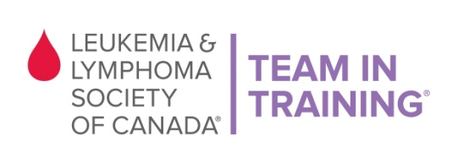

VOLUNTEER SIGN UP FORM

Thank you for volunteering your time with Team In Training at the Scotiabank Vancouver Half Marathon & 5K on Sunday, June 26, 2015.

Please register by Wednesday, June 22nd before 5pm.

About TNT: Team In Training is a comprehensive endurance-training program for runners and walkers to benefit The Leukemia & Lymphoma Society of Canada. The goal of Team In Training is to increase funding to support LLSC’s mission while promoting fitness and healthy lifestyles.

Full Name (required): | Age (if under 19):
Address: | City:
Phone: | Postal Code:
T-shirt Size (required): | E-mail (required):
Volunteer Opportunities

- Water Station #7

Event Details
- Sunday, June 26, 2015
- Duration time: 7:30am – 10:30am
- Location: Kits Beach - Cornwall Ave and Yew St (map will be provided)

LLS Waiver of Liability: I recognize and understand that there are risks associated with being a volunteer for The Leukemia & Lymphoma Society of Canada. I hereby waive and release any and all claims for injuries or damages I have against The Leukemia & Lymphoma Society of Canada, its directors, employees and other race volunteers caused by the negligence of any of them arising out of my participation as a volunteer. I, for myself and anyone entitled to act on my behalf, waive and release any and all claims for injuries or damages I have against The Leukemia & Lymphoma Society of Canada, its Directors and employees, any and all municipalities associated with the event I may be attending, the province of British Columbia, race volunteers, sponsors and/or their agents and representatives, caused by the negligence of any of them arising out of my participation in this event. I understand that as a volunteer I will not receive remuneration for the time or services I provide to The Leukemia & Lymphoma Society of Canada.

X_______________________________________________ __________ ____________________________________
(Volunteer’s signature or Parent/Guardian if under 19 yrs) (Date) (Please print Parent/Guardian name)

Please fax this form back to 604.733.2848 or e-mail to volunteerbcyukon@lls.org
Thank you!!!

The Leukemia & Lymphoma Society of Canada
Suite 303, 1401 West Broadway, Vancouver, BC V6H 1H6
volunteerbcyukon@lls.org
Phone: 604.733.2873 Fax: 604-733-2848

