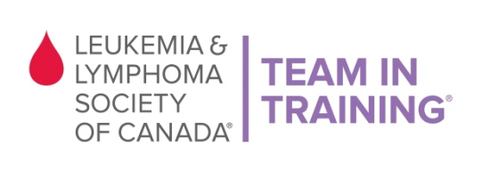

VOLUNTEER SIGN UP FORM

Thank you for volunteering your time with Team In Training at the Vancouver’s Hot Chocolate Run in Stanley Park on Saturday, March 7th, 2015.

Please register by Wednesday, March 4th before 5pm.

About TNT: Team In Training is a comprehensive endurance-training program for runners and walkers to benefit The Leukemia & Lymphoma Society of Canada. The goal of Team In Training is to increase funding to support LLSC’s mission while promoting fitness and healthy lifestyles.

Full Name: | Age (if under 19):
Address: | City:
Phone: | Postal Code:
T-shirt Size: | E-mail:
Volunteer Opportunities (please check one or more boxes)

- Race Package/Race Chip hand out
- Road marshaling
- Water station
- Cutting food and serving post-race
- Set-up
- Clean-up

Event Details
- Saturday, March 7th, 2015
- Duration time: 8:45am – 12:30pm
- Stanley Park Pavilion – 610 Pipeline Road, Vancouver V6G 1Z4

LLS Waiver of Liability: I recognize and understand that there are risks associated with being a volunteer for The Leukemia & Lymphoma Society of Canada. I hereby waive and release any and all claims for injuries or damages I have against The Leukemia & Lymphoma Society of Canada, its directors, employees and other race volunteers caused by the negligence of any of them arising out of my participation as a volunteer. I, for myself and anyone entitled to act on my behalf, waive and release any and all claims for injuries or damages I have against The Leukemia & Lymphoma Society of Canada, its Directors and employees, any and all municipalities associated with the event I may be attending, the province of British Columbia, race volunteers, sponsors and/or their agents and representatives, caused by the negligence of any of them arising out of my participation in this event. I understand that as a volunteer I will not receive remuneration for the time or services I provide to The Leukemia & Lymphoma Society of Canada.

X_______________________________________________ __________ ____________________________________
(Volunteer’s signature or Parent/Guardian if under 19 yrs) (Date) (Please print Parent/Guardian name)

Please fax this form back to 604.733.2848 or e-mail to volunteerbcyukon@lls.org
Thank you!!!

The Leukemia & Lymphoma Society of Canada
Suite 310, 1682 West 7th Ave Vancouver BC V6J 4S6
volunteerbcyukon@lls.org
Phone: 604.733.2873 Fax: 604-733-2848

