Student Transcript Service – Instructions
The Ministry of Education has created a new service where students can view, order and send transcripts to Post-Secondary Institutions or Employers electronically. ALL grads need to sign up for this service whether you choose to apply to Post-Secondary School or not.
Follow these steps:
- Go to the Ministry of Education’s Transcripts and Certificate website at http://www.studenttranscripts.gov.bc.ca  Or type “student transcript services” in the google search box then click Order Transcripts & Certificates and choose Current Student. Scroll down to see “Register for Basic BCEID” | 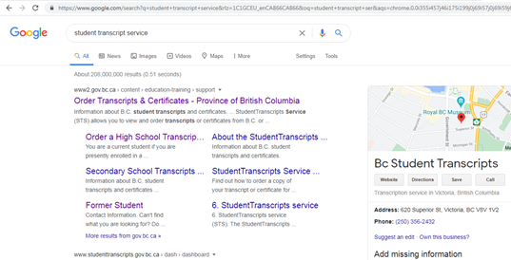
- Click SIGN UP for a Basic BCeID account  - Create an account using  - Full Legal Name  - Email Address (use your personal email ie gmail, yahoo)  - LOGIN ID should be your FIRST and LAST name with no spaces or punctuation  - Password is your choosing  - Click CONTINUE TO STUDENT TRANSCRIPTS  - Fill in form using  - PEN  - Full Legal Name  - Date of Birth  - Email address – use your personal email address ie gmail, yahoo) | 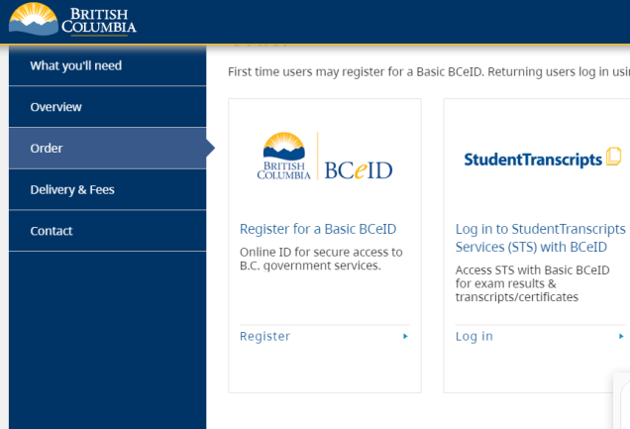
- Check your email for VERIFICATION. Click the link to verify. (Note: If you are unable to activate your registration after 24 hours, contact: studenttranscripts@gov.bc.ca for assistance)

7. LOGIN to account using Login ID and password

- Click SEND/ORDER TRANSCRIPTS

- Click I CONSENT

- Click SEND TRANSCRIPT

- Select all the schools you have applied to OR are planning to apply to. When selected, they move to the list box on the right side.

- Leave the selection as default unless the post- secondary institutions need a paper copy.

- When finished, select ADD TO CART

- Continue to CHECKOUT, select SUBMIT ORDER

*Please note: Some Post-Secondary Institutions may require your marks earlier than available through this process. It is your responsibility to find out what is required and when. Your marks will be transferred automatically through this process.

